Personal Database Setup

Overall Challenges:

The main difficulty in the database setup was to figure out a setup for the database tables so as to include everything efficiently and to not create redundant tables or columns. What helped majorly in figuring out this process however was the feedback that was given for our database setups that we used during the first part of the project and by simply following the feedback and combining the positive aspects that we used in each of our databases, we were able to come up with a way to compensate for everything.

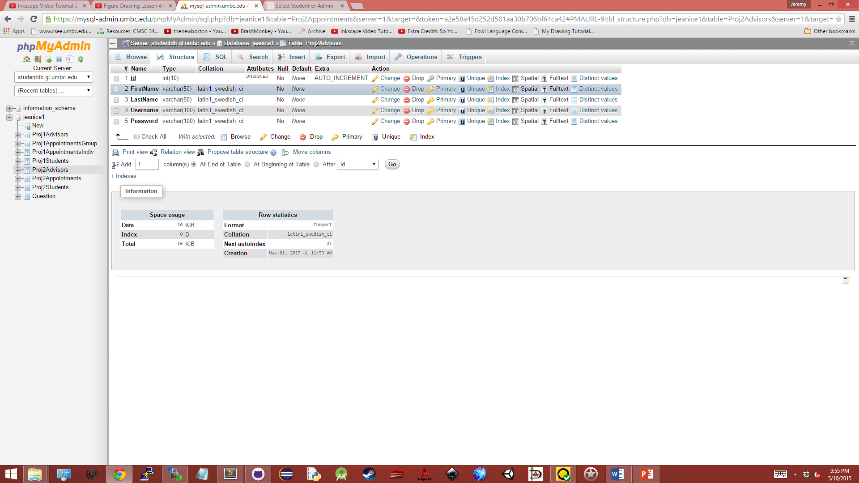

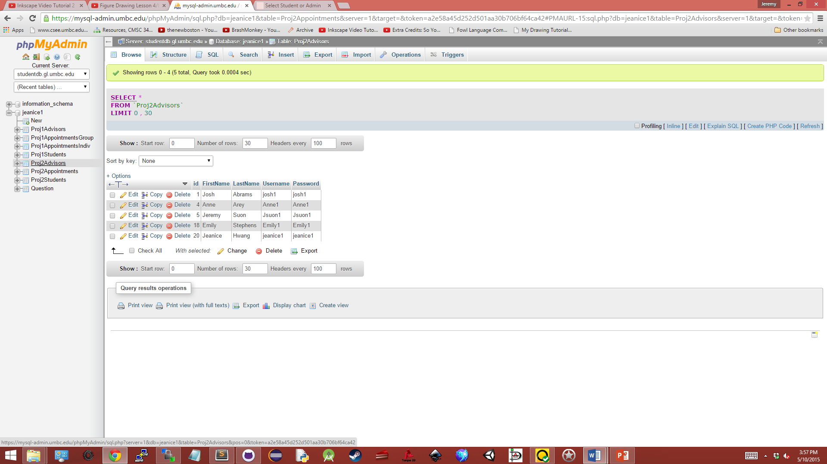

Advisor Table:

The first part of the database setup was accommodating all the advisors. A table for advisors was created in order to make it possible for new advisors to be included if a new advisor were to join the team. By doing this, we would allow a reference to be made to advisors by using their ID in order to identify/link them to appointments listed in another table.

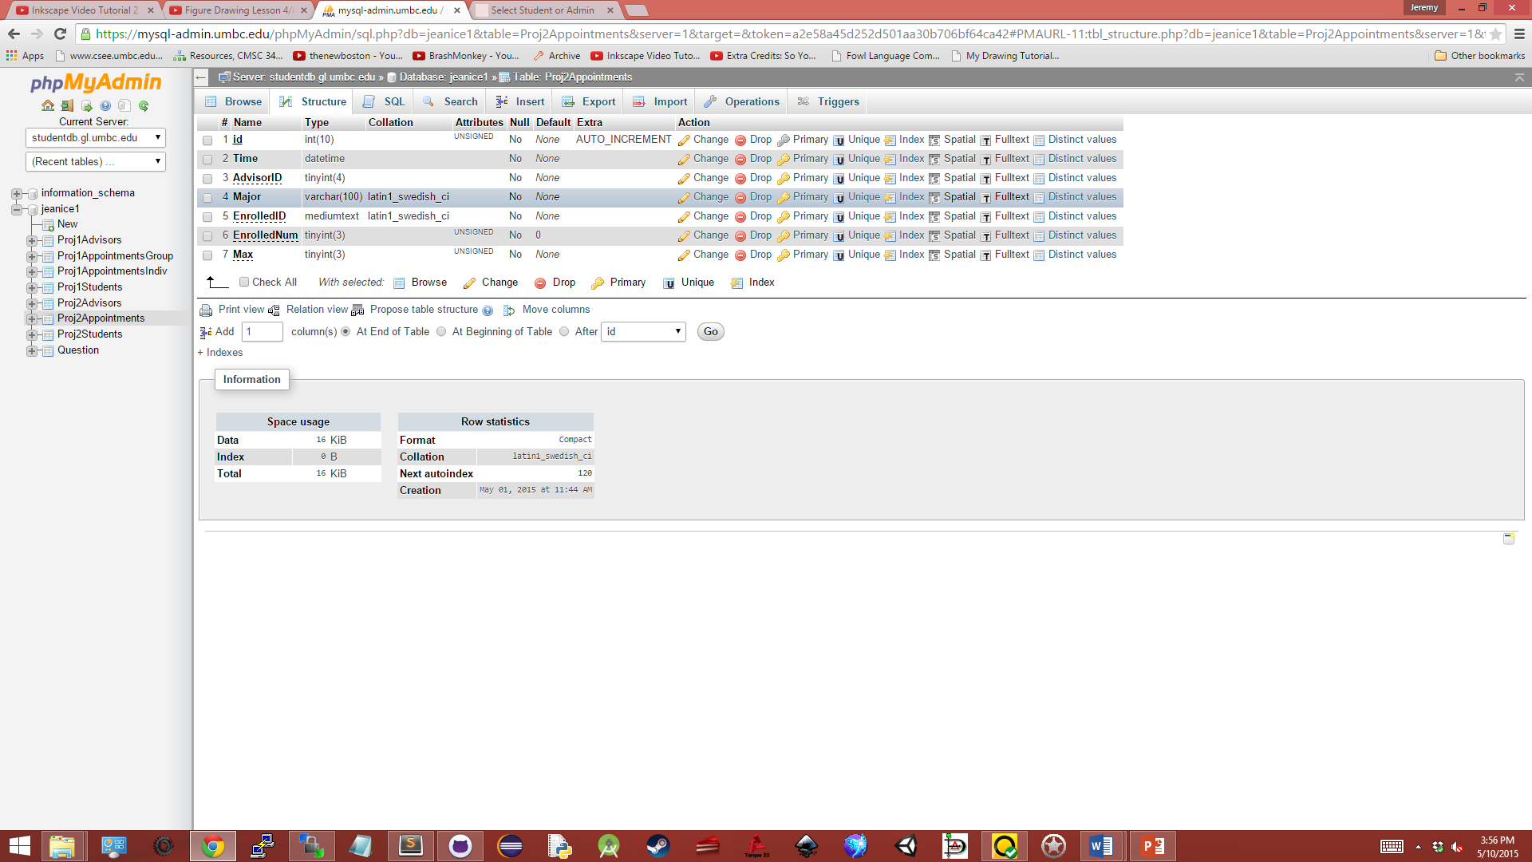

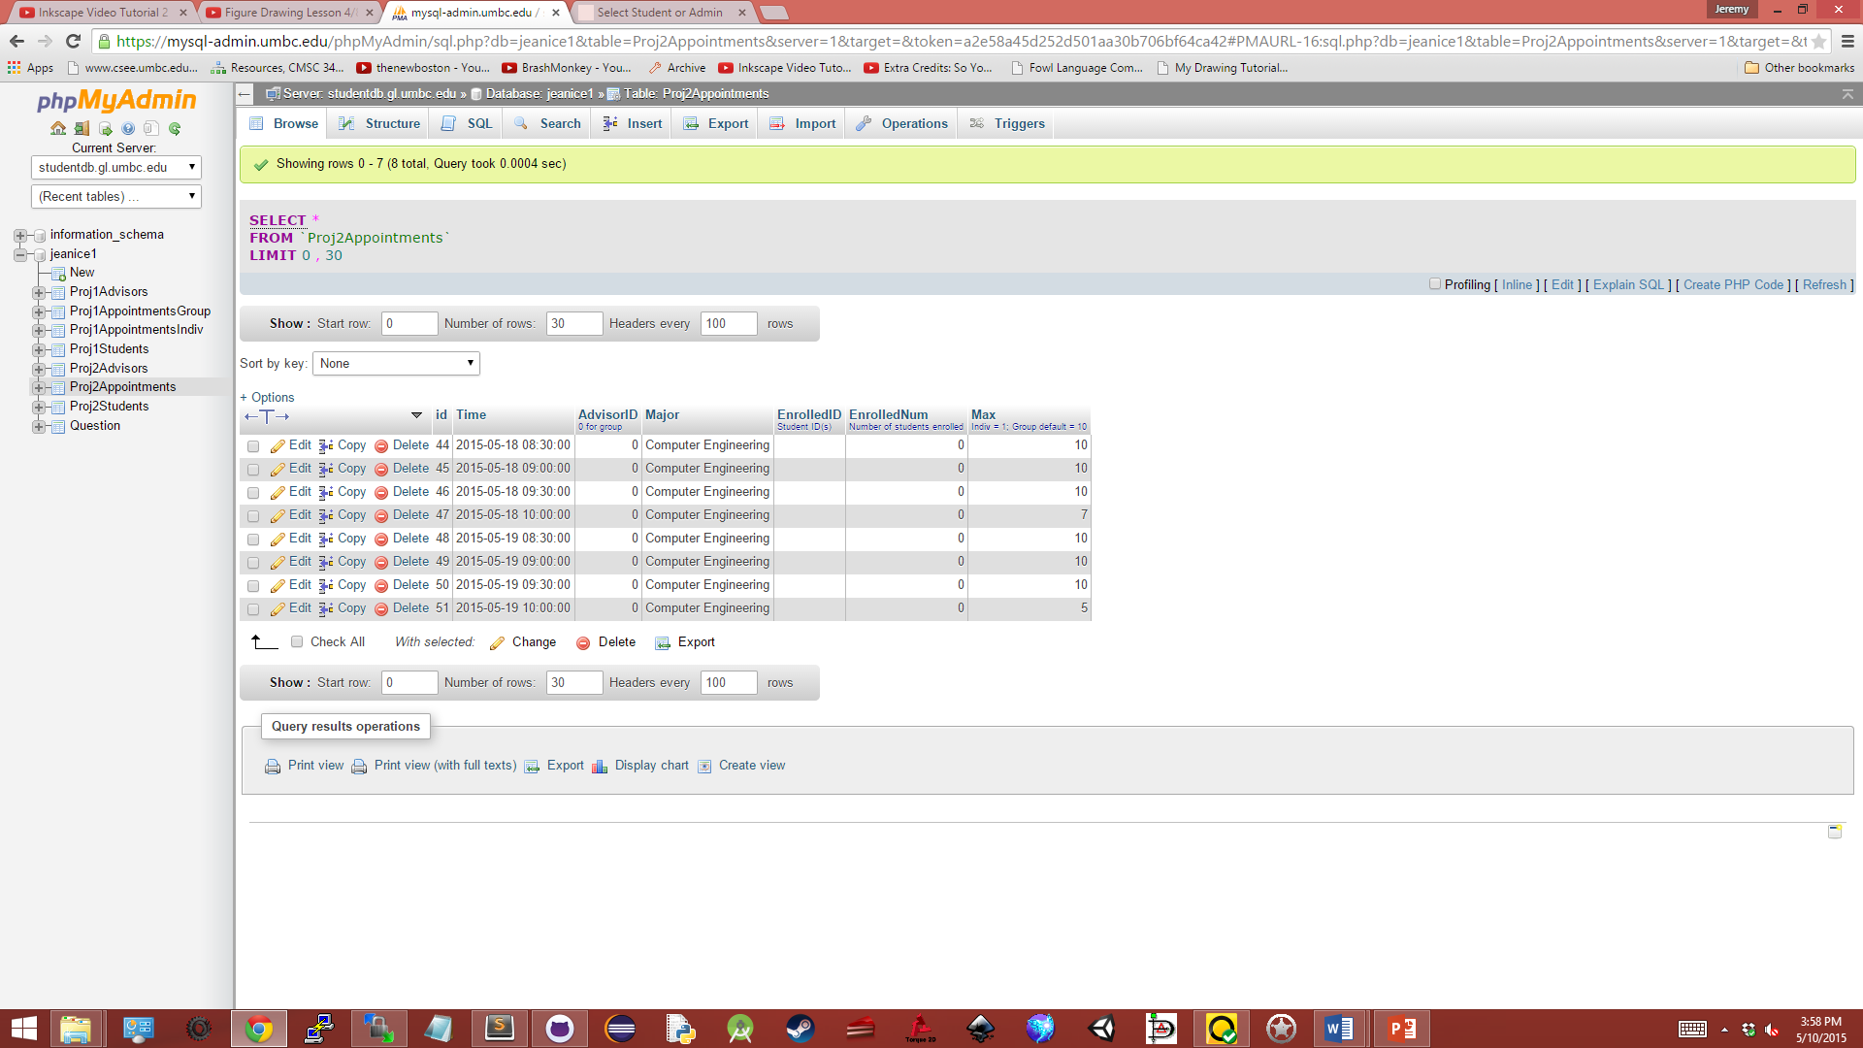

Appointment Table:

The next part of the setup would be the appointment table. To include all the information within the table so to make sure that it is linked to the other tables with more specific information about each part, we included IDs in the setup so we could identify to whom each appointment links to. Going through the different columns, an appointment would consist of a date-time format (shortened to Time), describing exactly when the appointment would take place; a major column, which is used to identify if an appointment is exclusive to specific majors. The field would be blank otherwise if the appointment is available to all majors. Following these, EnrolledID is a string used to store all student IDs that are scheduled for the appointment which can be further used to link to a student in the student table using their IDs in order to retrieve the information about the students that are scheduled for the appointment. EnrolledNum is used to show how many students are currently registered for the appointment and finally Max is used to identify the maximum amount of students that can be registered for an appointment.

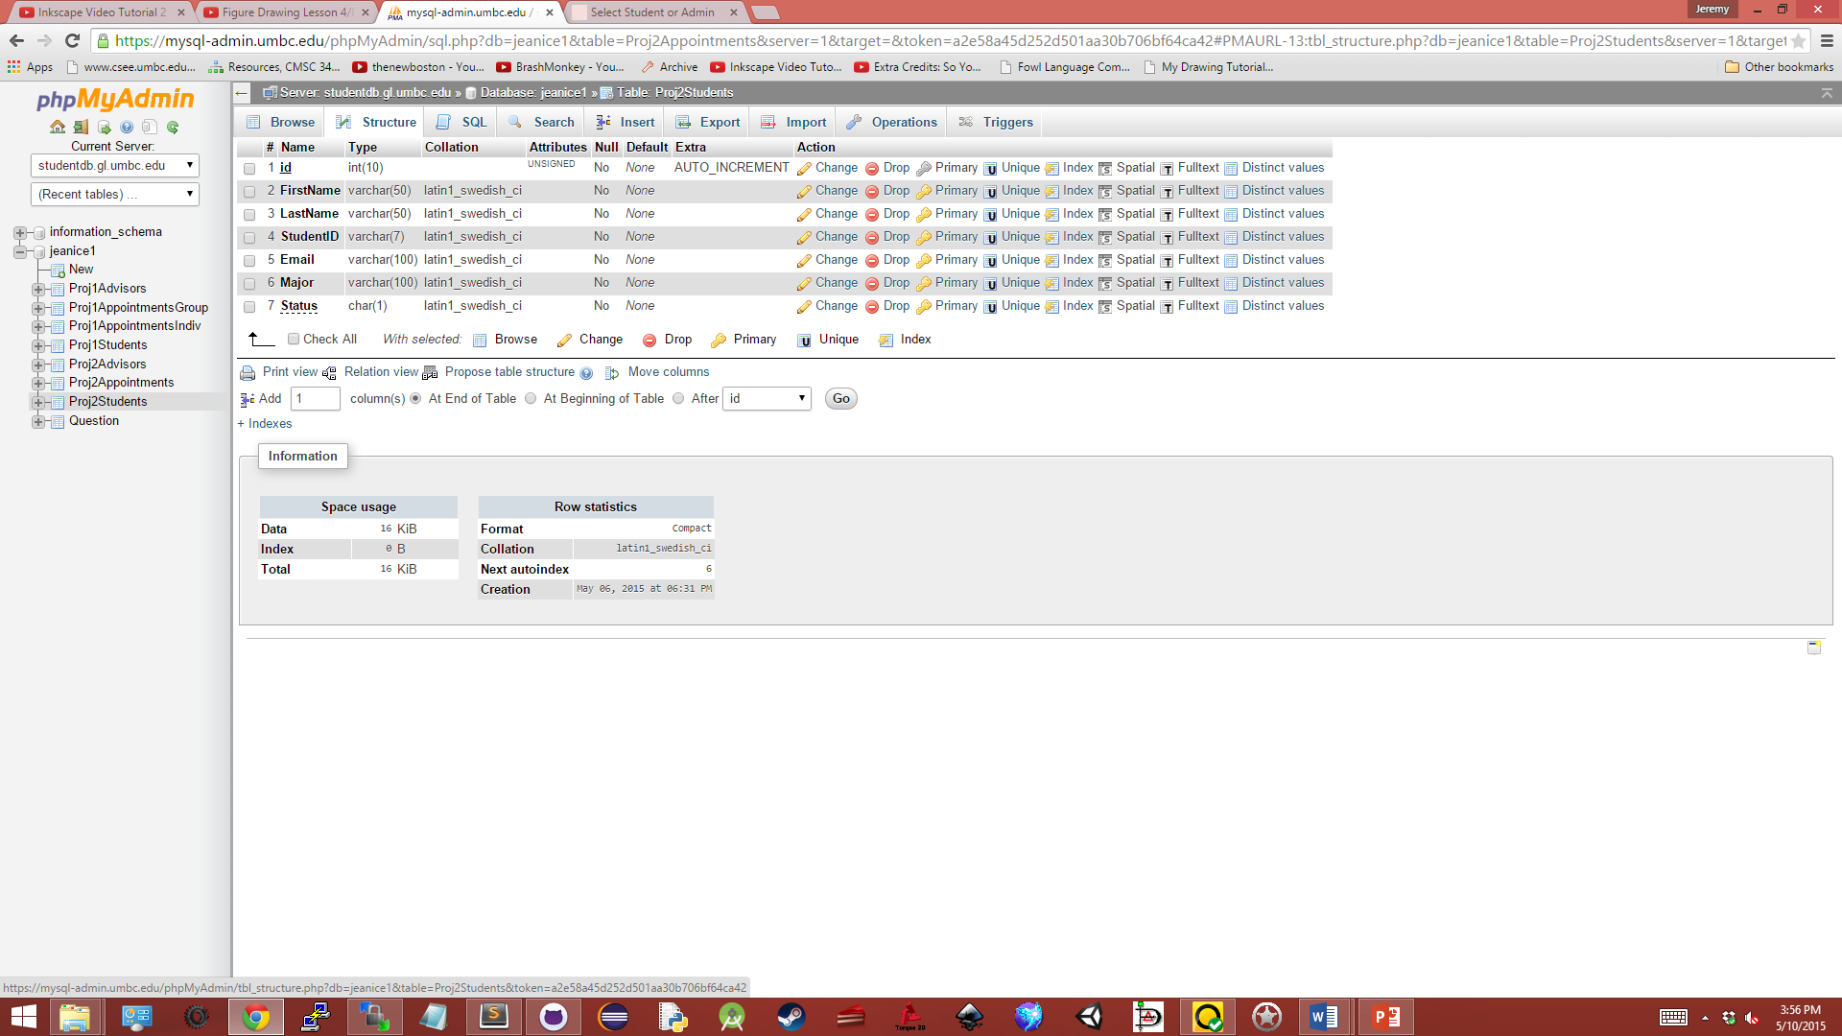

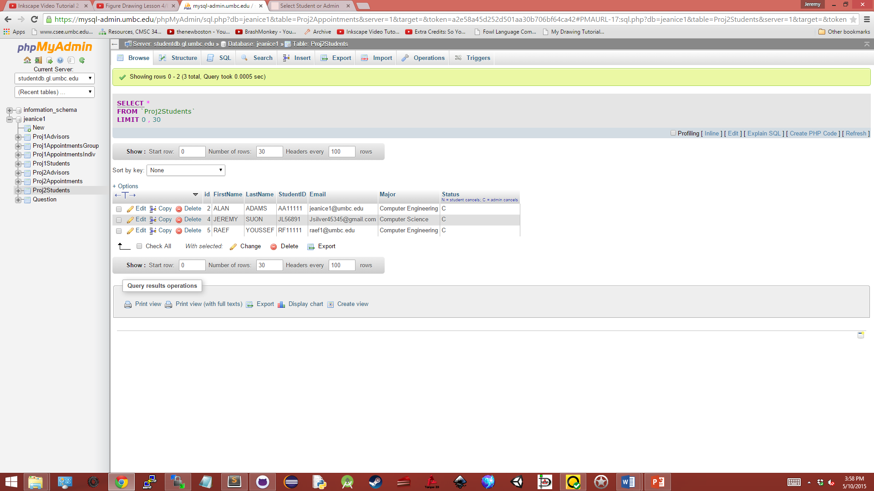

Student Table:

The last portion of the database setup is the student table. The table consists of an automatically incrementing id, created by the database; a FirstName and LastName for identification processes; a StudentID which is used in the appointment table in order to link the table to the students listed there; an Email, which is used in the email function of the website; and their major, which may be used to identify appointments specific to a major. The information stored about each student is generally used as needed within the website, or for editing within the student side of the site. Additionally, there’s a status field in the DB setup which is used to identify whether an appointment has been cancelled and who it was cancelled by. The field would read ‘C’ if an advisor were to cancel the appointment and ‘N’ if the student cancelled the appointment. The field would be blank if the student has an appointment.